DSAI HW3 Report

1. Different numbers of digit on subtractor:

3-digits(only 3):

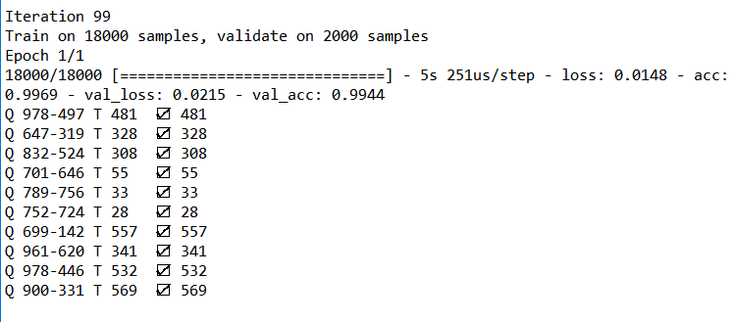

3-digits(0~999):

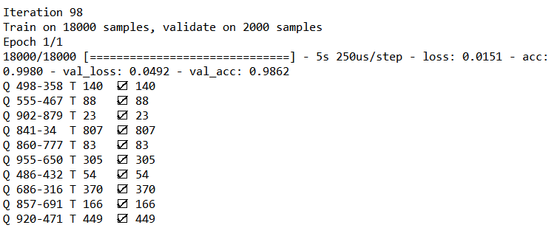

6-digits:

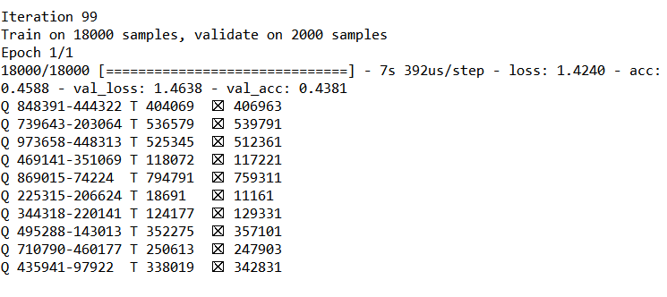

Obviously, the six digits subtractor performs poorly than the other two subtractors, since it may cause by the higher complexity of prediction, or the lack of training data (18000), we will add the training data size in the further discussion.

1. Training epoch ( use 3-digit sub as example)

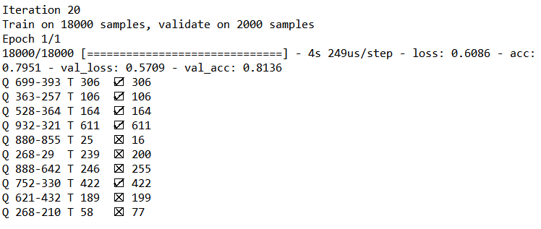



You can tell the diffenence between the two result of 20 epoch and 98 epoch of training, since the loss of training process tend to be dropping, the more epoch model learns, the more accuracy the model will reach, but under the premise that model doesn`t overfit or underfit.

1. Training size:

When training size goes to ten times larger than the original size, the accuracy is higher.

Multiplication on this model may not be the best option, since it is way more difficult than simply add two numbers together, i.e., multiplication are like adding two numbers multiple times, you have to decide how much time to add these numbers, thus based on this model it needs to gain more features, like adding times training, or the training of predicting the digits of the result.